**Server Side Scripting Assignment**

**Question 1**

The Client Server architecture model, which is the one shown below, is an application structure that splits tasks or objectives between the providers of a resource, also known as servers, and service requesters, called clients. Usually, both clients, as well as servers communicate over a network on separate hardware, although both may reside in the same system. A server host, then, carries out server programs which share their data with clients. On the other hand, clients do not share any of their resources, but request a server’s content. Clients, therefore, begin communication sessions with the servers which await incoming requests. Examples of PC applications that user this kind of architecture include Email, World Wide Web, and network printing. Another example is when a user accesses an online banking server. First, the client’s credentials are stored in the database, then the web server accesses the database as a client. After that, an application server “explains” the returned data by applying the bank’s business logic, and outputs the result on the web server. Finally, the web server sends and outputs the result to the client’s web browser for display.

Web Servers process static (which consists of a computer with an HTTP server) web pages by sending the files as-is, meaning that none of the information would be altered with. On the contrary, Servers process dynamic static (which basically is a static web server with an application server and a database) by updating the hosted files before delivering them to the user’s browser via the HTTP servers.

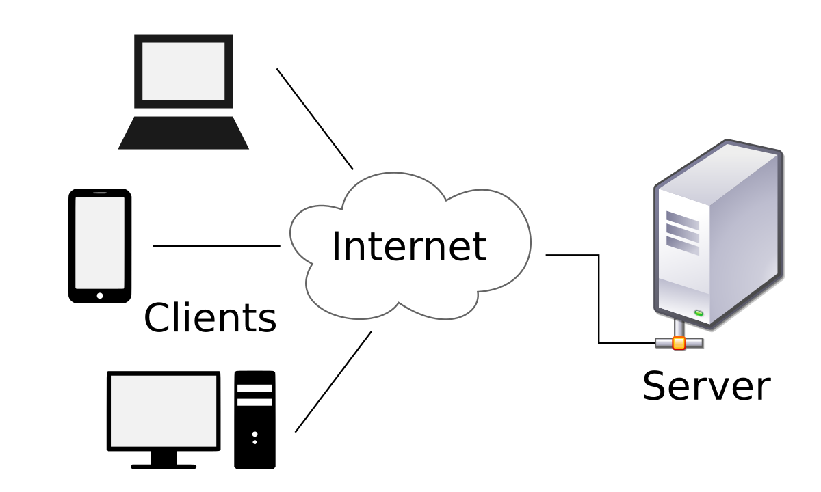

**Question 2**

The client-side technologies that I used in my assignment are:

1. HTML
2. CSS

The server-side technologies that I used in my assignment are:

1. PHP

Bundling can improve the performance of my website by reducing the number of requests to the server and reducing the size of the requested css and js files by combining them into one script. On the other hand, minification can help the performance of my website by analyzing and rewriting only the data that is required, at the same time, stripping off all “extra” data that is not required.

**Question 3**

MVC, which is short for Model View Control, is usually used for developing software that divides an app into three parts. This is done in order to separate the internal representations of data from the ways the information is being given to and accepted from the user.

This design’s pattern decouples the major components, allowing for efficient code reusability. An advantage of using this method is that, since MVC splits the components of an application, developers are able to work on different components without blocking one another.

For instance, a team might be divided into two groups; front-end developers and back-end developers. The back-end developers can develop and design the structure and how users will interact with it without requiring the user interface to be completed. On the other hand, front-end developers can design and test the layout of an application before the data structure is available.

Reference List:

<https://en.wikipedia.org/wiki/Model%E2%80%93view%E2%80%93controller>

<https://stackoverflow.com/questions/7045093/mvc-why-the-separation-of-model-view-and-controller?utm_medium=organic&utm_source=google_rich_qa&utm_campaign=google_rich_qa>

<https://blog.stackpath.com/glossary/minification/>

<https://www.c-sharpcorner.com/article/improve-application-performance-using-bundling-and-minification/>

<https://docs.microsoft.com/en-us/aspnet/mvc/overview/performance/bundling-and-minification>